Nama : Muhammad Riko Erlangga

NPM : 2141411

Bagian : Customer - Order (1)

# Join

* 1. Inner Join

Coding :

SELECT customer.customer_id, customer_name, customer_addres, order_id, orde r_date, qty, amount FROM customer INNER JOIN orders ON customer.customer_id

= orders.customer_id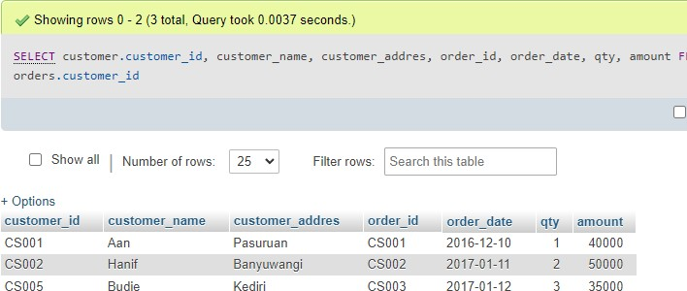

# Left Outer Join

# Coding :

SELECT customer.customer_id, customer_name, customer_addres, order_id, orde r_date, qty, amount FROM customer LEFT OUTER JOIN orders ON customer.custom er_id = orders.customer_id

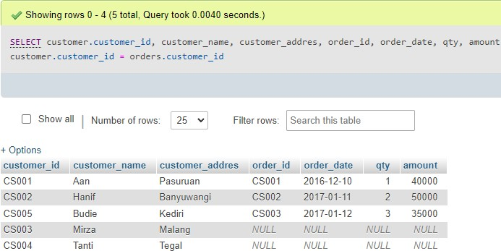

# Union

# Coding :

SELECT customer.customer_id, customer_name, customer_addres, order_id, orde r_date, qty, amount FROM customer INNER JOIN orders ON customer.customer_id

= orders.customer_id UNION ALL SELECT customer.customer_id, customer_name,

customer_addres, order_id, order_date, qty, amount FROM customer LEFT OUTE R JOIN orders ON customer.customer_id = orders.customer_id

